Feature: Animal(s) is/are selected

        In order to determine which animal names were selected & their

appropriate sounds

    As a user

    I want to select a variety of animals to learn which sound that they make

        Background: none are selected in the beginning, but given one or more

are selected.

        #End Background

***#Scenario1*** Animals: two animals are selected

               Scenario: two animals are selected

        Given there are five options to choose from, but none have been

selected yet

               And the user selects two checkboxes

               But values will now be determined

        When the user clicks ‘get animal names’

               And ‘get animal sounds’

        Then the two names of the animals will appear within the list box

below ‘get animal names’

               And the two sounds that the animals make will appear below

‘get animal sounds’

               But ‘reset’ will allow all entries to be cleared

               And ‘exit’ will have a message pop-up that asks to confirm the

user’s request to exit the system

        Examples:

        | Example 1: cat & cow | Example 2: duck & pig|

        #End Scenario1

#***Scenario2*** Animals: three animals are selected

        Scenario: three animals are selected

        Given there are five options to choose from, but none have been

selected yet

               And the user selects three checkboxes

               But values will now be determined

        When the user clicks ‘get animal names’

               And ‘get animal sounds’

        Then the three names of the animals will appear within the list box

below ‘get animal names’

               And the two sounds that the animals make will appear below

‘get animal sounds’

               But ‘reset’ will allow all entries to be cleared

               And ‘exit’ will have a message pop-up that asks to confirm the

user’s request to exit the system

               Examples:

        | Example 1: cow, duck & pig | Example 2: duck, pig & rooster |

        #End Scenario2

**Scenario 1 screenshots**

**Example1: Cat and Cow**

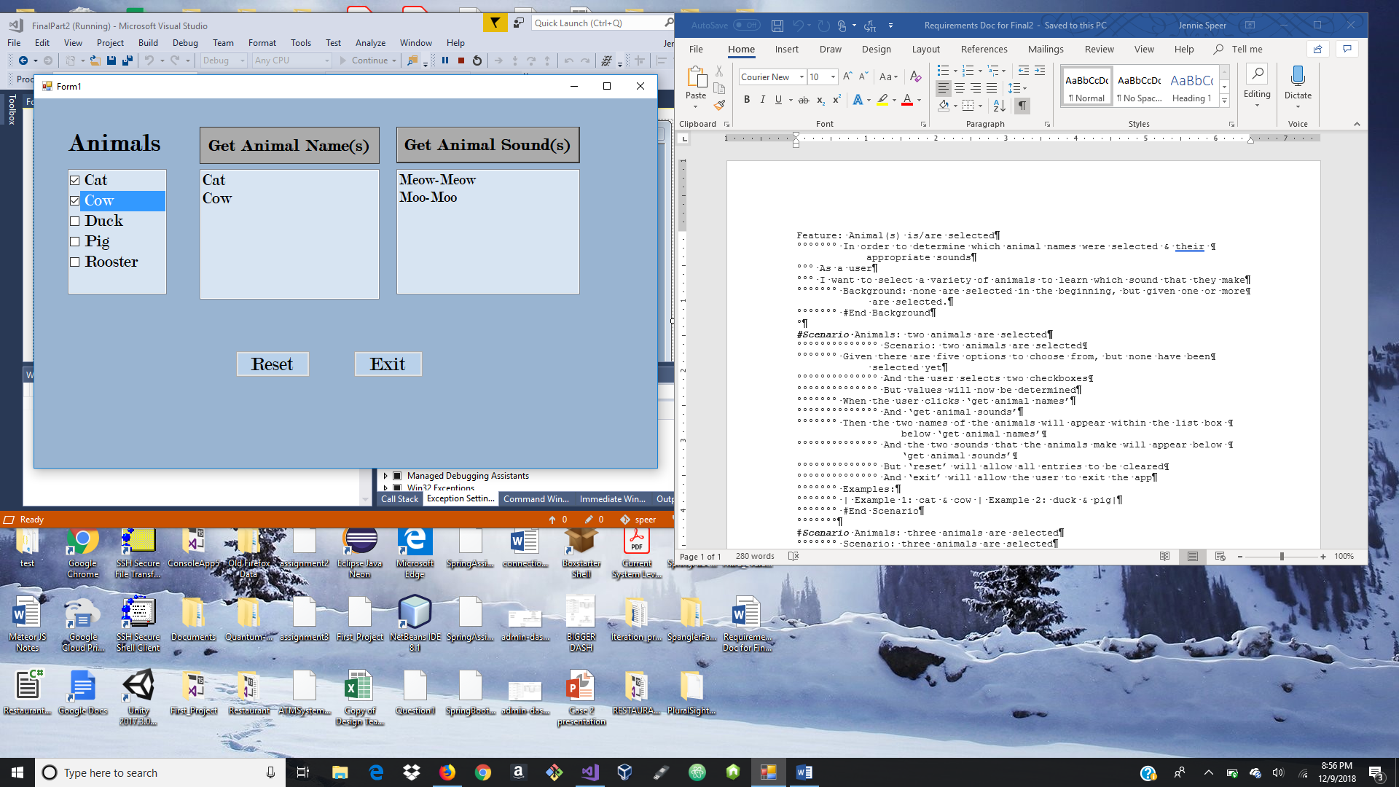

**Reset**

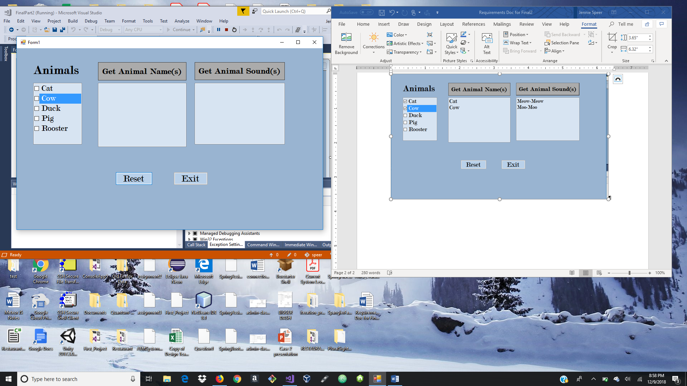

**Example 2: Duck and Pig**

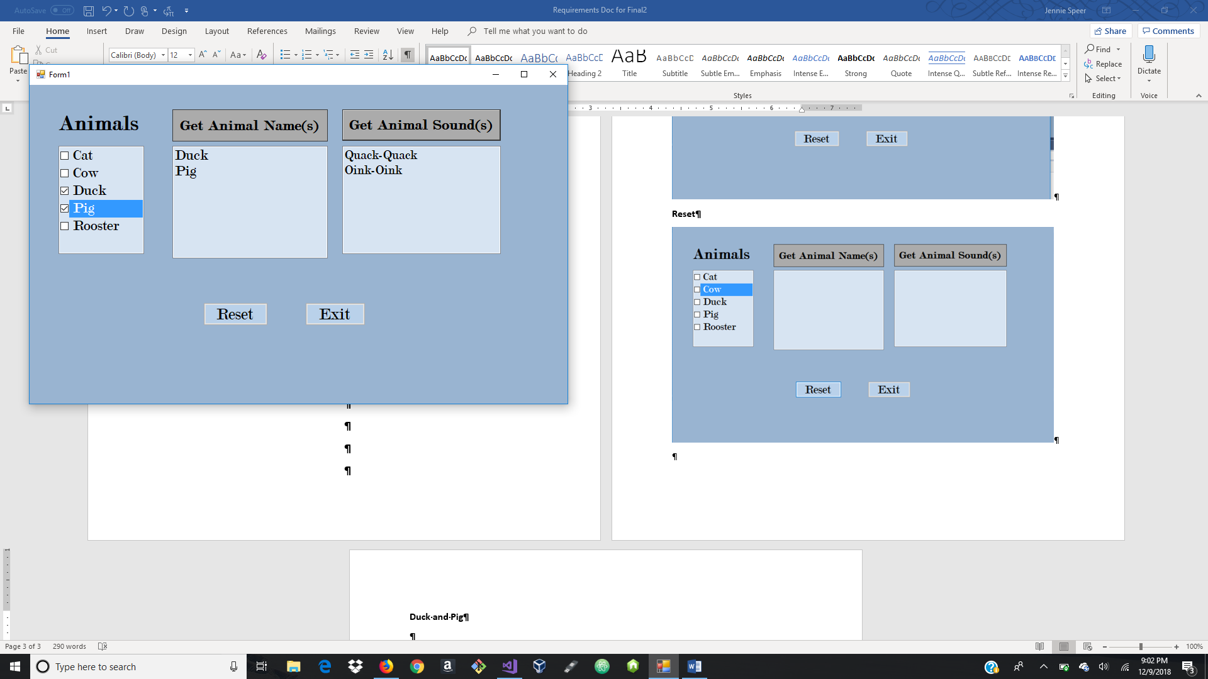

**Scenario 2 screenshots**

**Example 1: Cow, Duck and Pig**

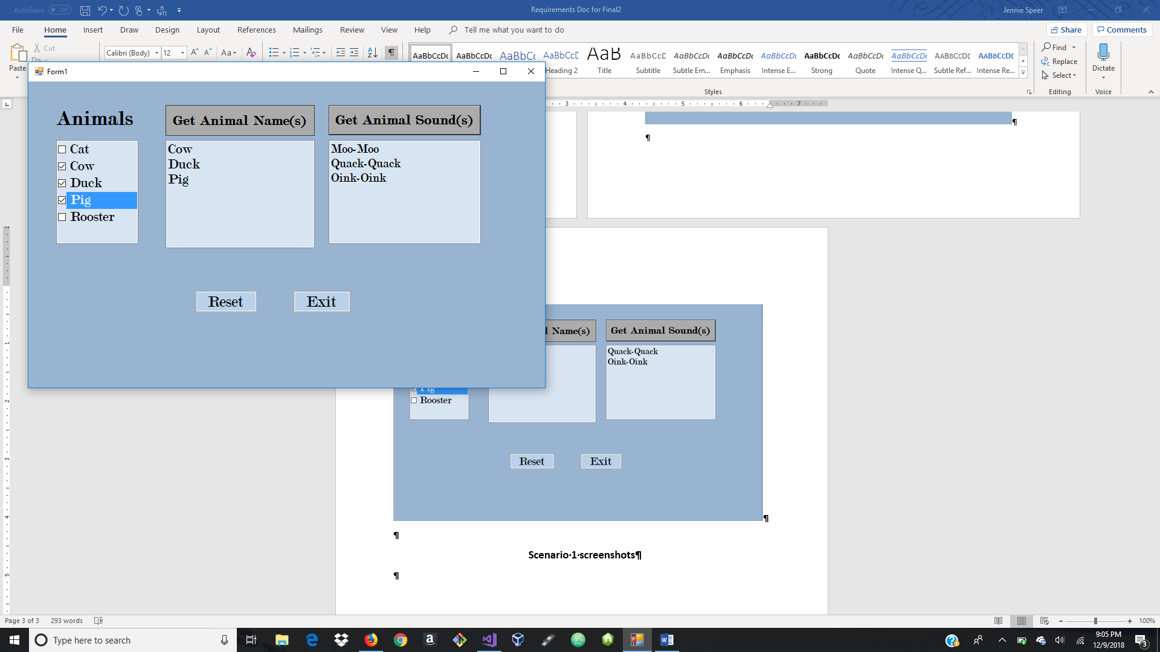

**Example 2: Duck, Pig and Rooster**

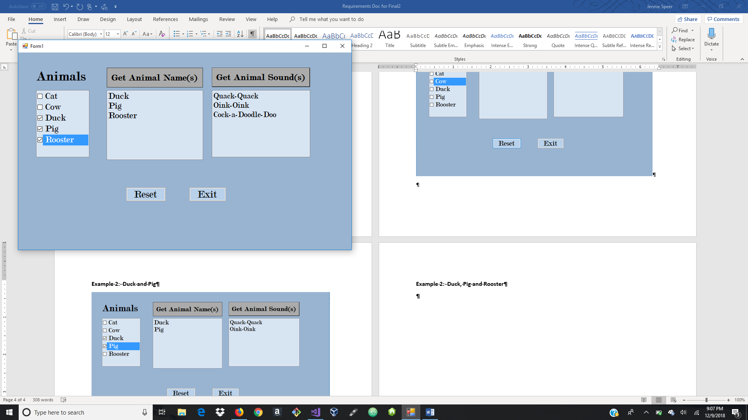

**Exit**

